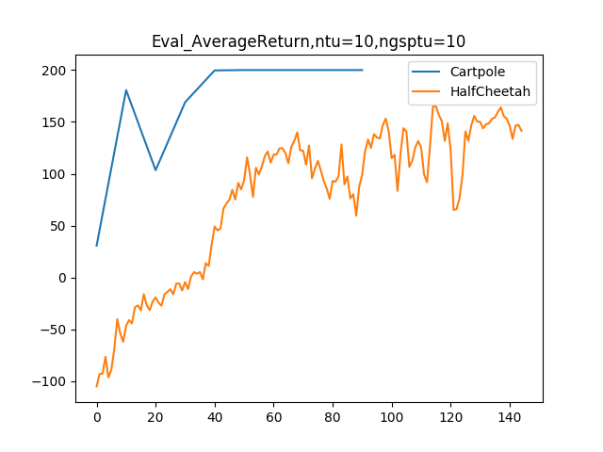
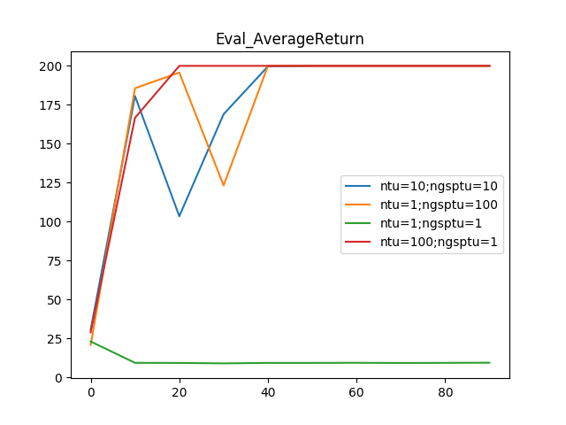

Actor Critic method is essentialy consist of two things:
Policy Evaluation and Value Improvement Step

Here Value improvement step is done by policy gradient method which is know as Actor and Policy evaluation step is done by Critic , which in our case is estimating State value by function approximation.

->Policy Evaluation Step :
Suppose we have the policy π and we want

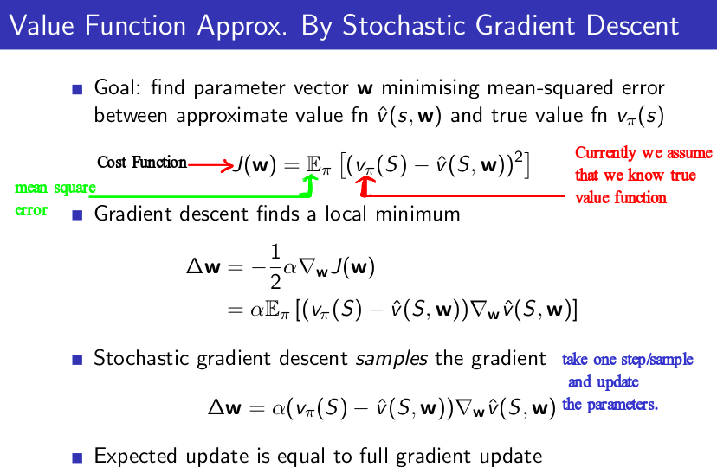
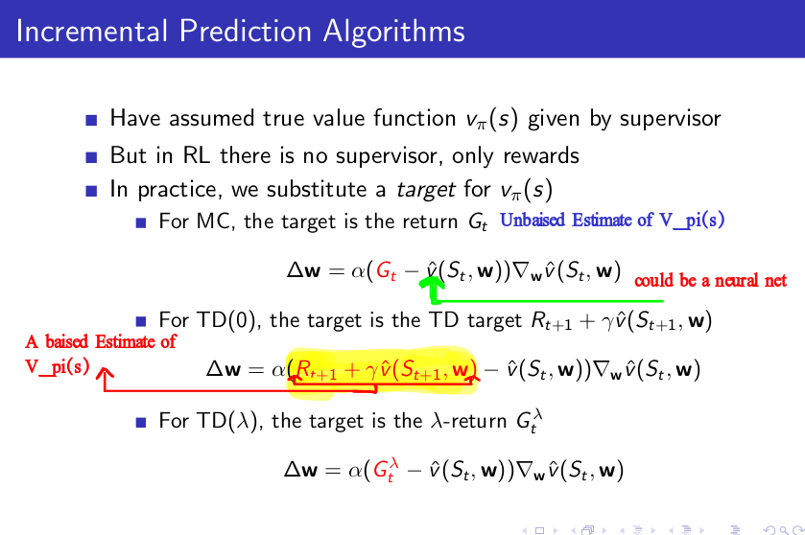

In general when there is linear function estimator function to estimate the Value function the stochastic gradient desecent with TD(0) converge, but when we move towards the non linear function approximation with TD(0) Bootstrap this method does not converge theoritically as well as in practice.

